## 5_15_15_Logitech Logo_RGB-1

## Fact Sheet

**Logitech® M220 Silent Mouse**

### A portable quiet mouse with an 18-month battery life and strong wireless connection.

### Announcement Date: Aug. 31, 2016 Shipping: October 2016

**Price**: 689 CZK **Available at**: www.logitech.com

### Product Description

With the same “click” feel and over 90 percent noise reduction (verified by Quiet Mark™) when compared with the Logitech M170, the Logitech**®** M220 Silent Mouse offers a quiet experience for you and your neighbors – whether at home or in the office. With the M220 Silent, you can depend on a wireless connection of up to 33 feet, thanks to the tiny USB receiver. It works with Windows®, Mac®, Chrome OS™ or Linux®, no software needed. Enjoy smooth, precise moves on almost any surface with Logitech Advanced Optical Tracking. The M220 mouse has an 18-month battery life with auto-sleep, so it automatically puts itself to sleep when not in use. The M220 Silent is the first mouse to receive the Quiet Mark seal of approval from the Noise Abatement Society. Its small size is perfect to toss in a bag and go.

### Key Features

* Work quietly: Experience the same “click” feel and over 90% noise reduction of the click sound. The M220 Silent features a rubber wheel for quiet scrolling and the feet are made of high-performance material for quiet gliding.
* Simple. Reliable. Strong: Enjoy a wireless connection up to 33 feet (10m) away\*\*, thanks to the included plug-and-forget nano receiver. With the Logitech Advanced Optical Tracking, the M220 Silent delivers ultra-precise moves on almost any surface. And, the M220 Silent works with Windows, Mac, Chrome OS or Linux-based computers.
* 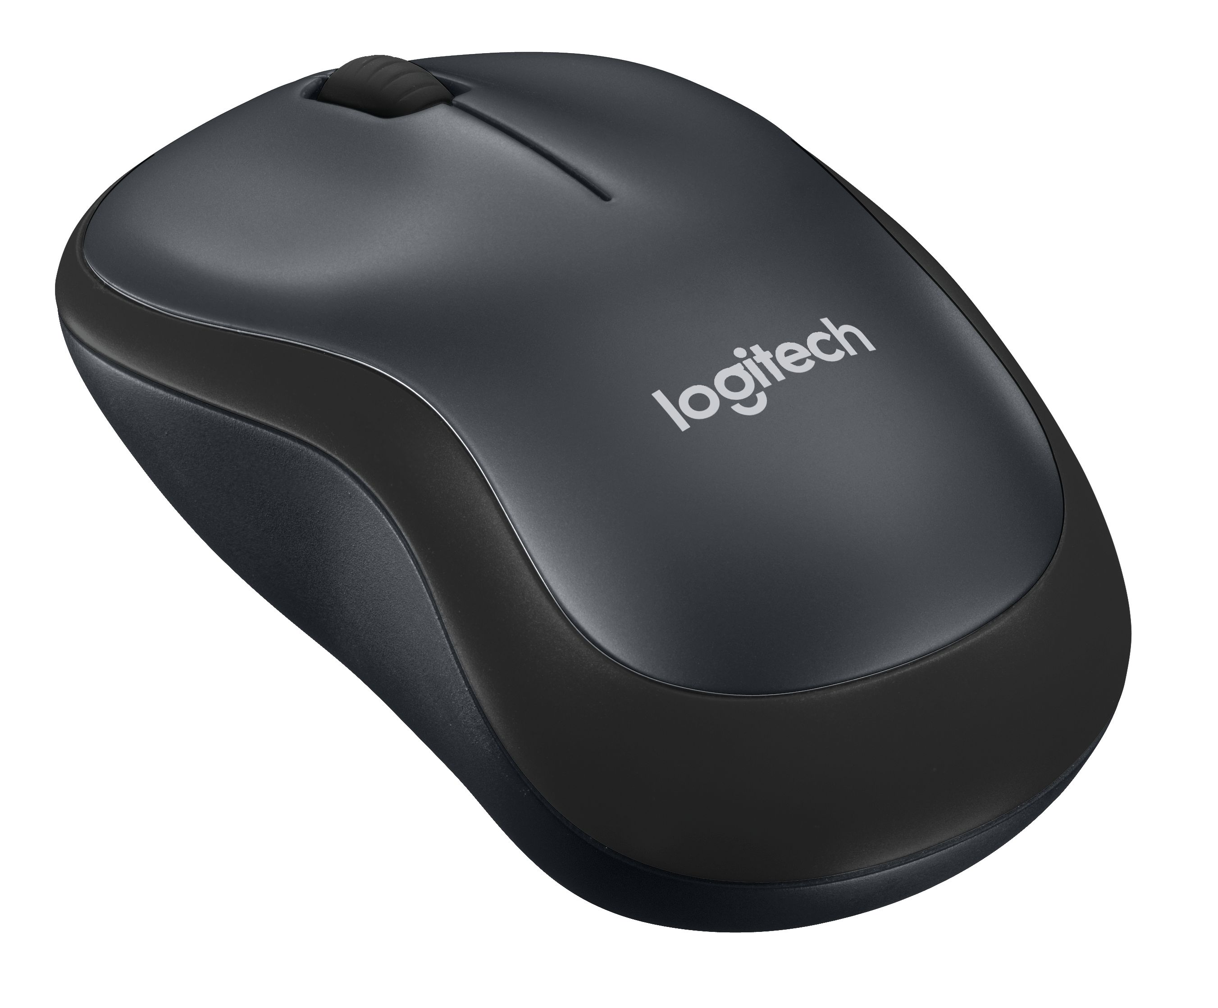18-month battery life: With the M220 Silent, you can go longer between battery changes because the mouse automatically puts itself to sleep when not in use.
* Comfortable shape. Mobile size: The ambidextrous design provides more comfort and precision than your touchpad.

### System Requirements

### Windows® 10, Windows® 8, Windows® RT, Windows® 7

### Mac OSX 10.5 or later

### Chrome OS

### Linux Kernel 2.6+2

### Powered USB port

### Product Specifications

* Mouse Dimensions:
  + Height: 3.89 in (99 mm)
  + Width: 2.36 in (60 mm)
  + Depth: 1.54 in (39 mm)
* Weight (including battery): 2.65 oz (75.2 g)
* Number of buttons: 3
* Sensor technology: Logitech Advanced Optical Tracking
* Sensor resolution: 1,000 dpi
* Logitech Advanced 2.4 GHz wireless connectivity

### Warranty

* 2-year limited hardware warranty (EMEA and JP)

### Press Contact

Leona Daňková

TAKTIQ COMMUNICATIONS s.r.o.

+420 605 228 810

[leona.dankova@taktiq.com](mailto:leona.dankova@taktiq.comn)